|  |
| --- |
| Digital Analyst Team |
| Installation Document |
| Installation Ver 1.2 |

|  |
| --- |
| Varghees S  11/5/2016 |



# Document Control

**Revision history**

| Version | Issue date | Author/editor | Description/Summary of changes |
| --- | --- | --- | --- |
| 1.0 | 11/05/2016 | Varghees S | First Draft |
| 1.1 | 12/20/2016 | Varghees S | Deploying the war from script section updated |
| 1.2 | 01/27/2017 | Varghees S | Change for Lead2Sale and Cookie application |

**Reviewed by**

| Version | Issue date | Name | Position | Review date |
| --- | --- | --- | --- | --- |
| 1.0 |  |  |  |  |
|  |  |  |  |  |
|  |  |  |  |  |

**Approvals**

| Version | Issue date | Name | Position | Approval date |
| --- | --- | --- | --- | --- |
|  |  |  |  |  |
|  |  |  |  |  |

# Table of Contents

Netbeans 4

Cloning the repository 5

Building the application 7

Sprint TAG 8

Apache Tomcat installation 9

Creating Database in MySql 10

Deploying the WAR locally (Manual) 11

Deploying the WAR in AWS (Manual) 11

Deploying the WAR from script 12

Login into Cookie application 13

SSH Access to Development/QA server 14

Login into MySql server 14

MySql DB dump backup 14

MySql DB dump restore 14

**Netbeans**

Version 8.1or 8.2 - Quick Installation Instructions

* Download link: <https://netbeans.org/downloads/>
* Select Java EE bundle and click download.

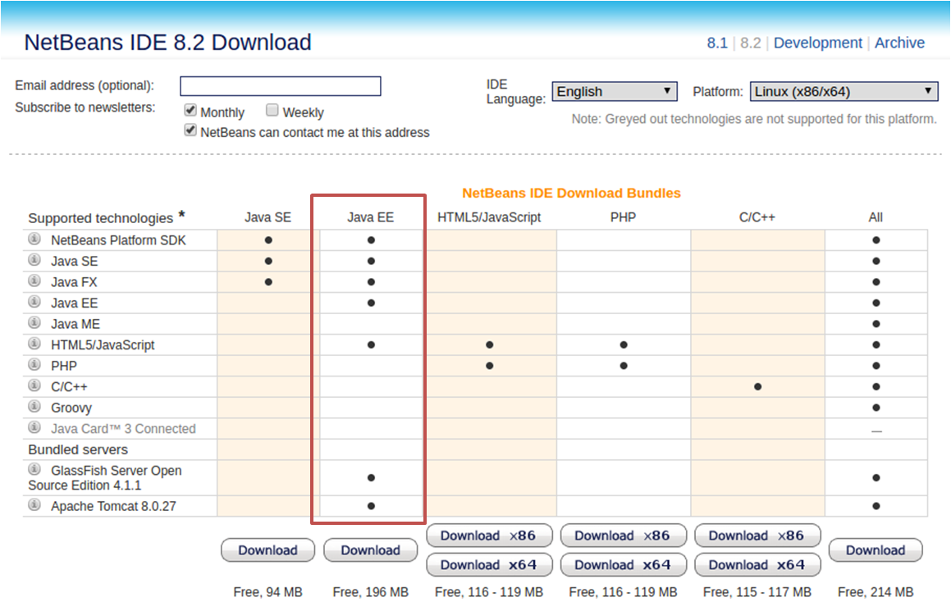

* Save the installer file to your system
* Run the installer as follows
  + *$ chmod +x <installer-file-name>*
  + *$ ./<installer-file-name> to run the installer*

Note: Make sure **Java 1.8** is already installed and **JAVA_HOME** is set

* Follow the installation instructions

Note: Choose **Apache Tomcat** for application server

For more details visit: <https://netbeans.org/community/release/81/install.html>

**Cloning the repository**

Cloning the repository

* Login to **github** using below URL

<https://github.com/login>

* Sign in to GitHub, provide your user name and password

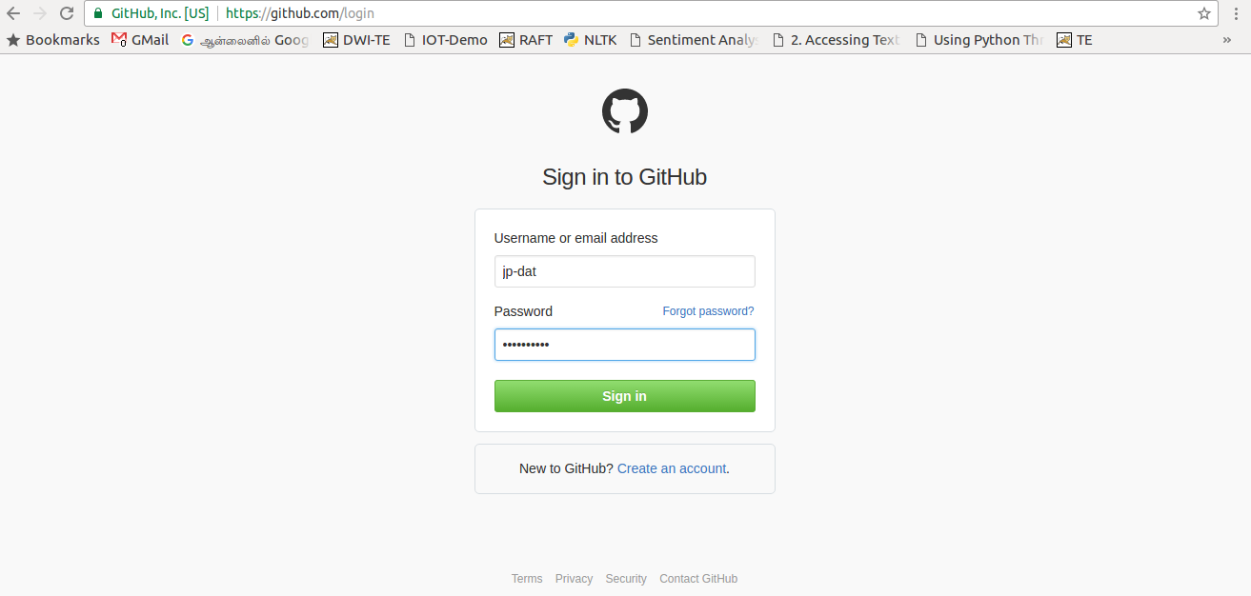

Successful login will take you to the below page

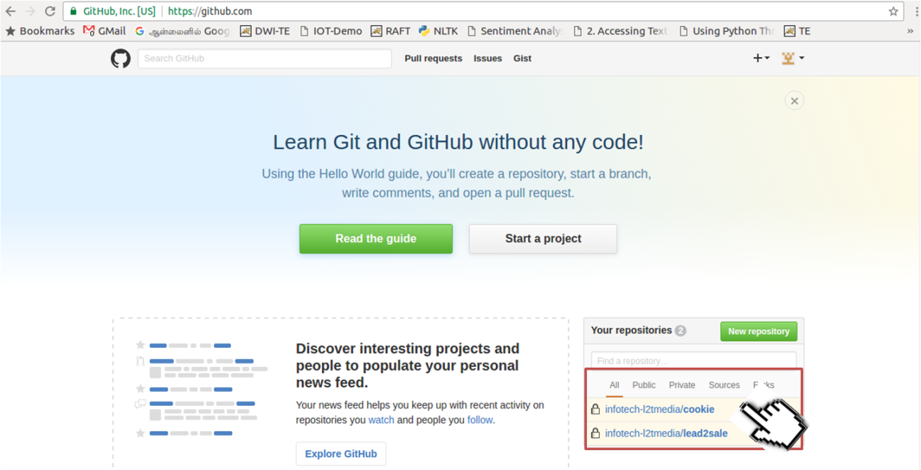

Choose the **cookie** project for Clone or download

Select **Copy to clipboard** icon

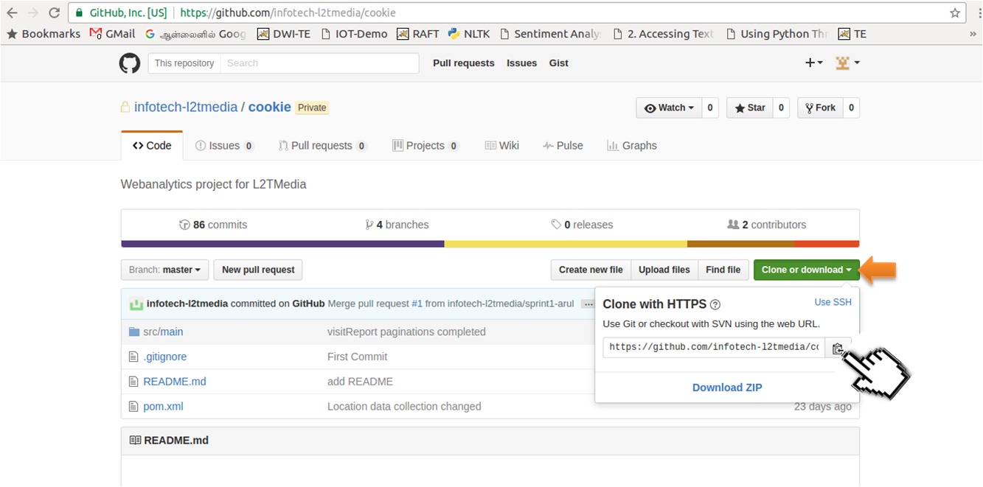

* Change the directory to **Netbeans** using **cd** command
* Past the copied clone command into command prompt and press Enter
* Enter user name
* Enter password

Example:

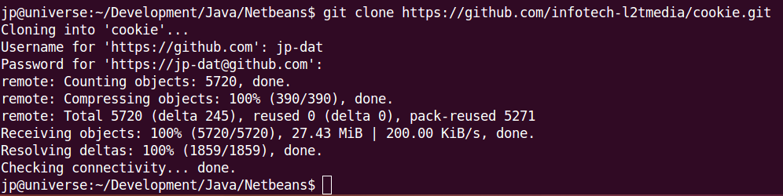

Wait until the download to complete.

**Building the application**

* Run **Netbeans**
* Select **Open project** from **File** menu choose cookie

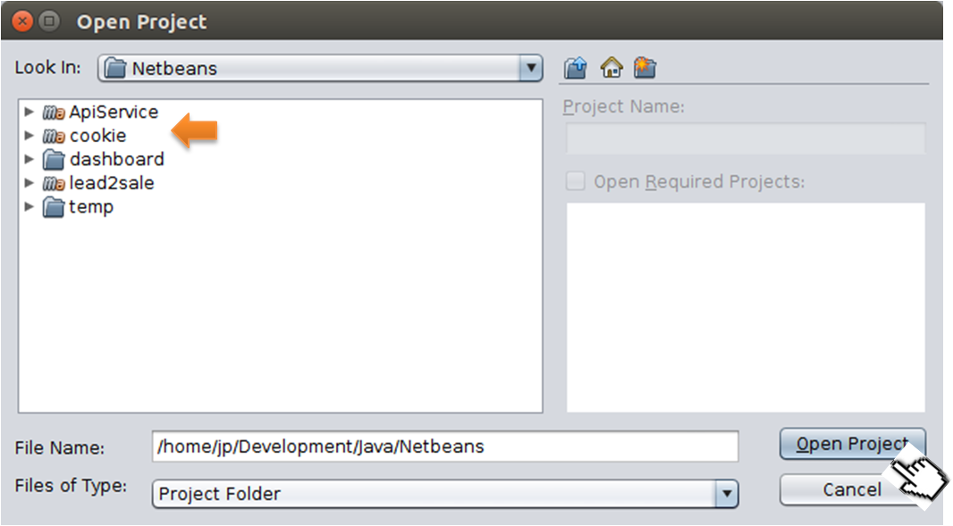

It will load the project as below

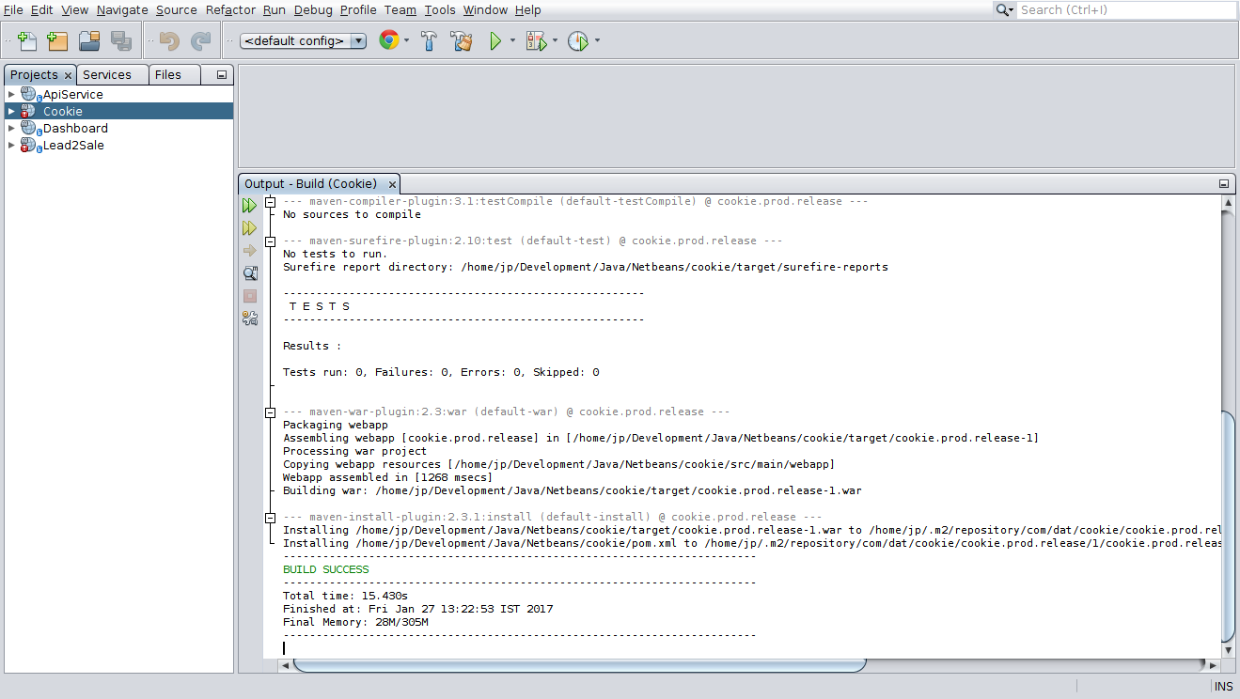

Select the project **Cookie/Lead2Sale** then right click and choose **Clean and build** from the menu

Wait until the build process to complete

WAR file will be created under **cookie/target/** directory in the name of **Product.[devqa/prod].<Sprint-[version]>.war**

**Sprint TAG**

Each build deployed into development + QA environment will contain the sprint tag.

<PRODUCT>.<[PROD/DEVQA]>.<**RELEASE**>-<NUMBER>.war

Example:

cookie.devqa.sprint-1.war

**Apache Tomcat installation**

Download Apache Tomcat from the below link:

<https://tomcat.apache.org/download-80.cgi>

Un tar the downloaded **.tar.gz** file as below

*$ tar –xvxf apache-tomcat-8.0.38.tar.gz -C* ***<DESTINATION_DIRECTORY>***

Note: Make sure **Java 1.8** is already installed and **JAVA_HOME** is set

Change directory to **apache-tomcat-8.0.38/bin/**

Run **startup.sh** and **shutdown.sh** script for verification

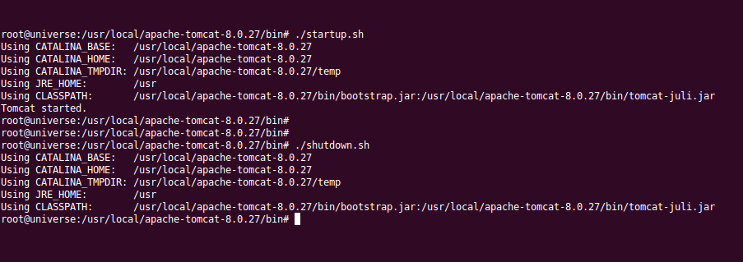

It should show the successful message for Tomcat start/shutdown as above.

**Creating Database in MySql**

It is assumed MySql is already installed in the system, if not please follow the below link

<https://dev.mysql.com/downloads/installer>

Example: Creating Database **wa** in MySQL, refer the below image

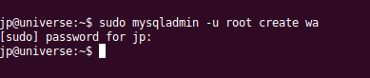

**Deploying the WAR locally (Manual)**

* Copy the created **cookie/target/cookie.devqa.sprint-1.war** file into apache-tomcat-8.0.38/webapps/
* Rename the **cookie.devqa.sprint-1.war** into **cookie.war**
* Start the Apache Tomcat server

*$ startup.sh*

**Deploying the WAR in AWS (Manual)**

Login into AWS

*$ ssh –i* ***/path-to/L2TAWSKey.pem*** *ubuntu@ec2-52-88-45-181.us-west2.compute.amazonaws.com*

Shutdown the existing Apache Tomcat server

*$ cd /opt/tomcat8.5/bin*

*$ ./shutdown.sh*

From build server(local) copy the war to AWS

*$ scp –i* ***/path-to/L2TAWSKey.pem*****cookie.devqa.sprint-1.war** *ubuntu@ec2-52-88-45-181.us-west-2.compute.amazonaws.com:/opt/tomcat8.5/webapps/*

Start the Apache Tomcat in AWS

Note: Assuming **L2TAWSKey.pem** file is available locally, if not download the same from AWS console

**Deploying the WAR from script**

**Script steps in deployment**

1. Shutdown Apache Tomcat server running in QA/Production
2. Copying the .war file into QA/Production environment
3. Create a directory and extract the .war
4. Copy the appropriate database.properties into QA/Production
5. Start the Apache Tomcat server

**Executing script**

Name of the script : deploy.sh

*$ sh deploy.sh* <Enter>

**How script works**

Display the menu with below details:

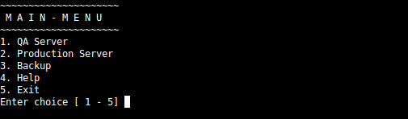

Select the required choice (Example QA server)

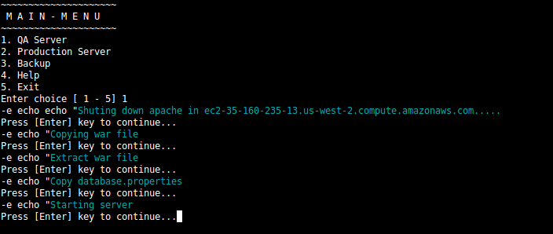

It does all the above steps then it will go back to main menu.

After the server is started user can login into Cookie application

**Login into Cookie application**

***<SERVER_ADDRESS>:***8080/webanalytics/index.html

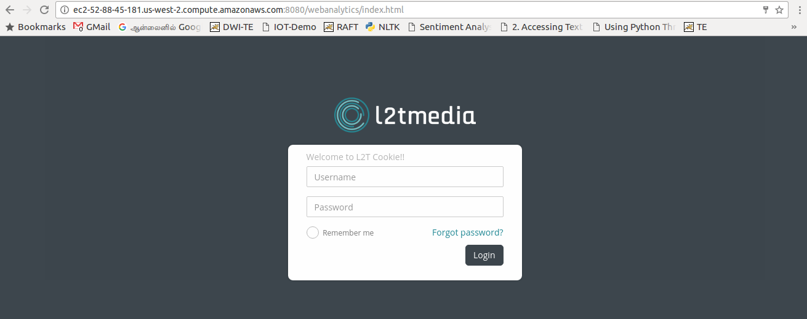

**SSH Access to Development/QA server**

*$ ssh –i* ***/path-to/L2TAWSKey.pem*** *ubuntu@ec2-52-88-45-181.us-west2.compute.amazonaws.com*

The above command will login as ubuntu user in Development/QA server

**Login into MySql server**

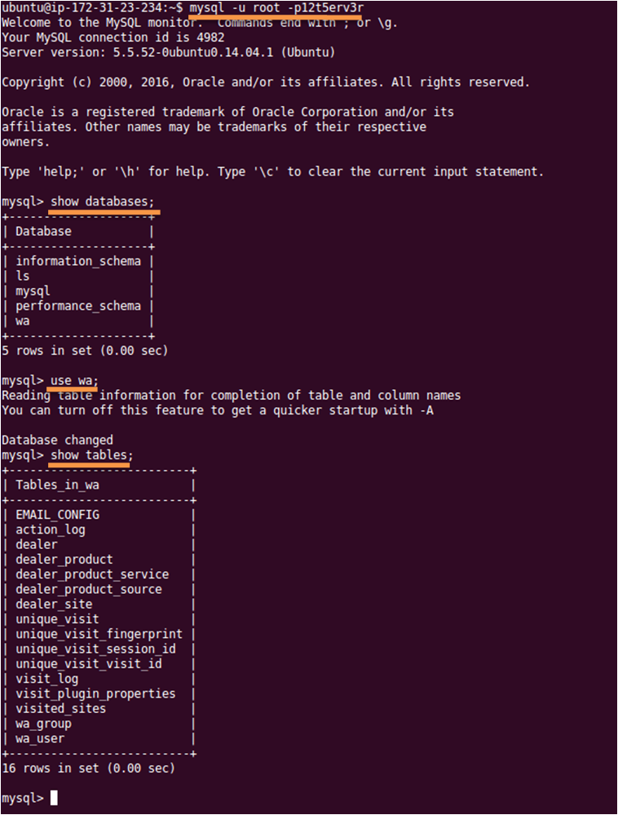

**MySql DB dump backup**

*$ mysqldump –u root –p<password> wa > wa.sql*

The above command will take the backup of wa database into wa.sql

**MySql DB dump restore**

*$ mysql –u root –p<password> < wa.sql*

Note: Make sure wa database is already exists, if not create the same as below

*$ mysqladmin –u root –p<password> create wa*